**Getting Started with VS-code - running Jupyter Notebooks**

**What is it purpose of this document?**

In this document we will outline the basics of navigating and using VS-code to run Interactive Python Notebooks (ipynb) fresh from installation. We will go through creating files, setting up extensions to run .ipynb files and write your first piece of code.

**What is an Interactive Python Notebook?**

An Interactive Python Notebook, often saved with a .ipynb extension, is a file format used for interactive computing and data analysis. It allows users to create and share documents that prototype projects, easily debug and create reusable workflows explained by markdown cells containing text, making it a popular choice for data and research scientists.

**Setting up VS code, extensions and creating .ipynb files**

Once installed you should be greeted with this welcome page – and can select light or dark mode which ever you prefer

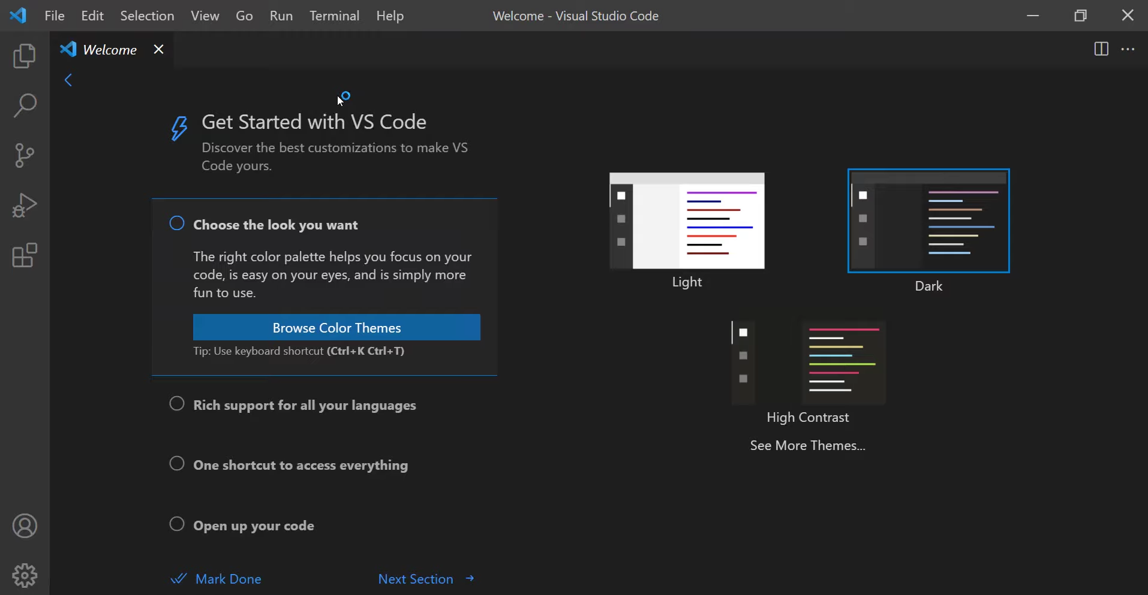

**Getting extensions for running .ipynb files**

**What are extensions?**

Extensions in Visual Studio Code, like the Python extension, are add-ons that expand the editor's capabilities.

We will install 2 extensions Python and Jupyter.

The Python extension provides features such as intelligent code completion, debugging support, virtual environment management.

The Jupyter extension allows the user to create, edit, and run Jupyter Notebooks directly within VS Code.

**How do we install them?**

Extensions are found by clicking the boxes icon on the left of the VS code menu, search and install the Python and Jupyter extensions

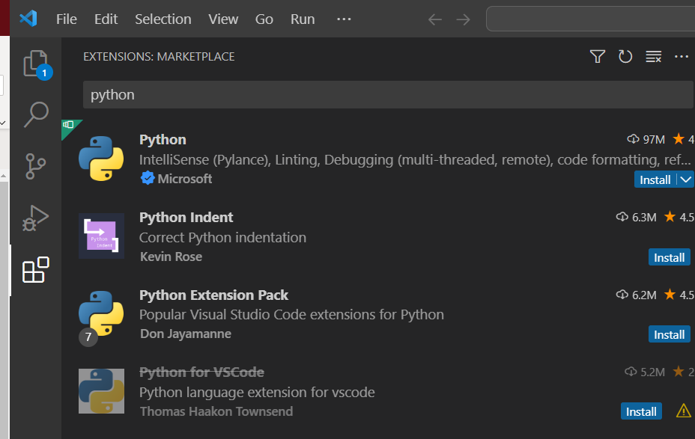

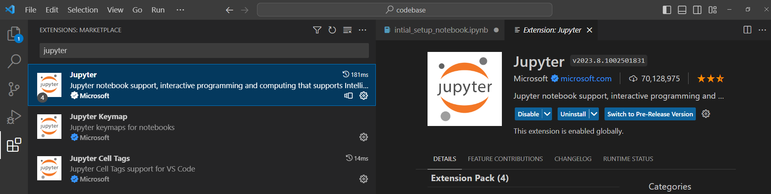

You should also be prompted to install this extension when running a notebook in the next section.

**Creating .ipynb files**

Create a new folder in you documents called codebase – notice how the name is lower case and is logical in it naming – this can be done via the file explorer or VS code

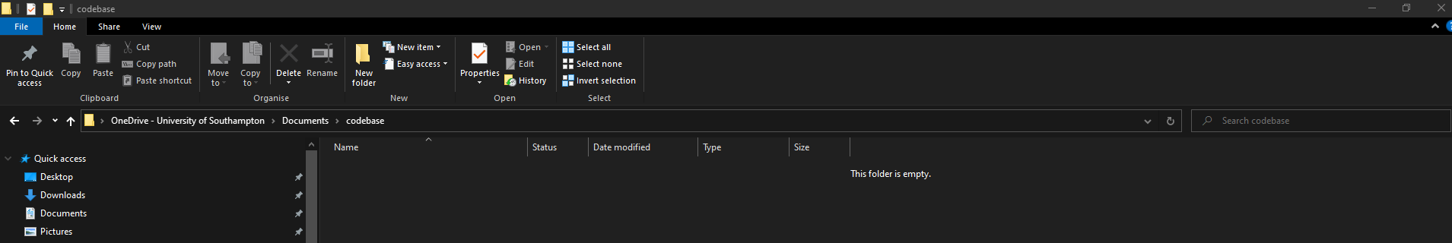

Now open the folder you have created through VS code, highlight codebase folder in your documents and click ‘select folder’

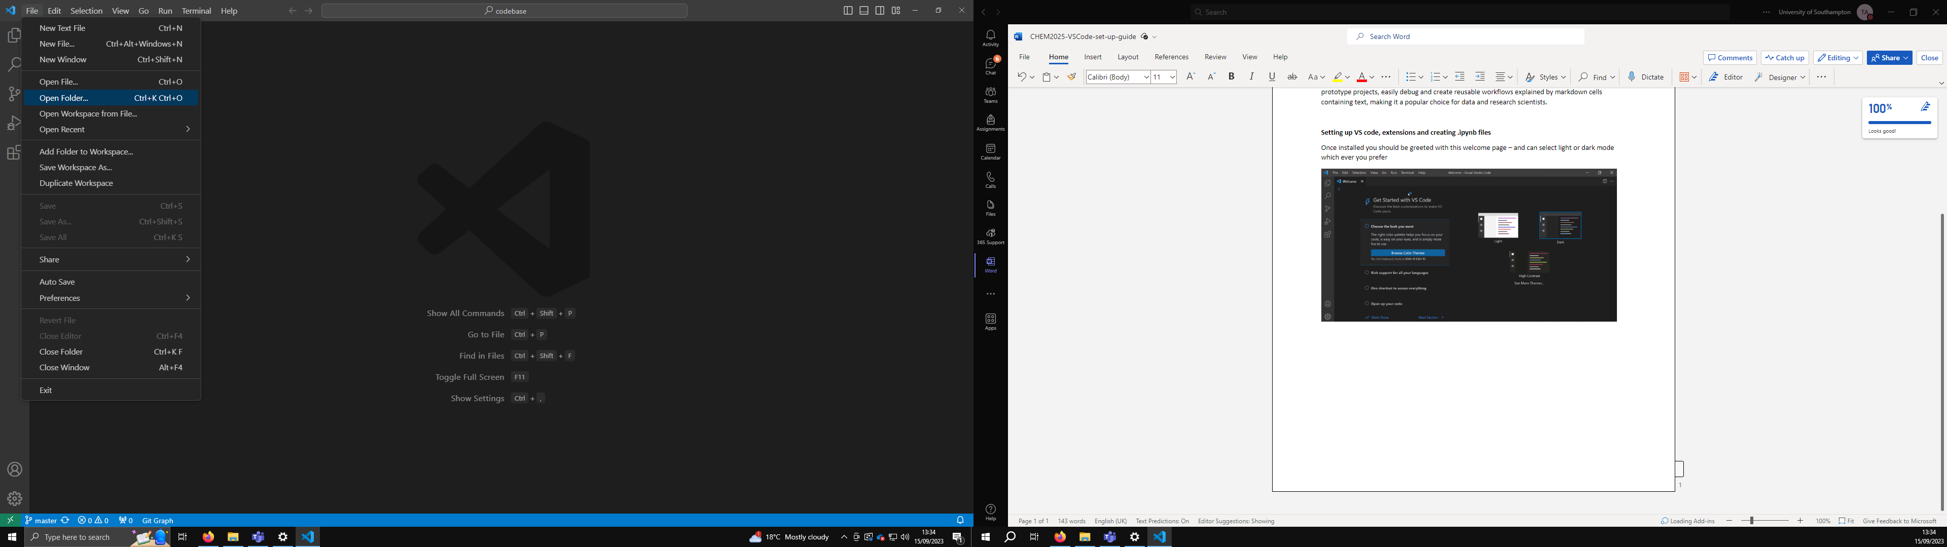

Your folder should be opened within VScode, now you can create a new folder – if you were on a course called ‘chem 2025’ name the folder chem2025 or chem_2025 as its best practice to not include spaces when naming files.

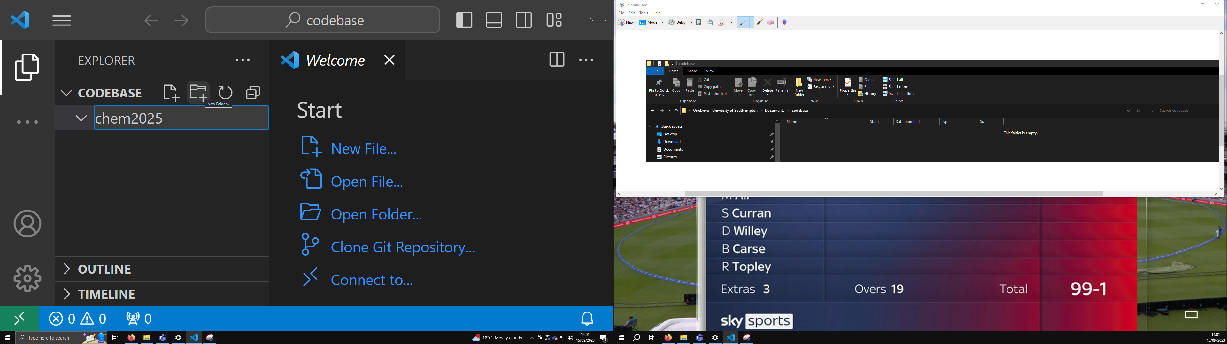

Create a file with the file extension .ipynb if done correct the icon next to the file will change to a blue notebook

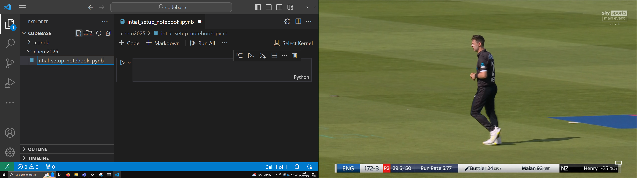

Create the file and open it

**Setting up a Kernel**

Now we need to setup the Anaconda environment previously created as a kernel in VS code to run the Interactive Python Notebooks.

A Kernel is an engine that interprets and executes code within interactive environments like Interactive Python Notebooks, enabling the processing and display of results for the user. Separate Kernels are set up to operate for different environments.

Below is how we set up the kernel, click on select kernel in the top right corner

Select Python environments

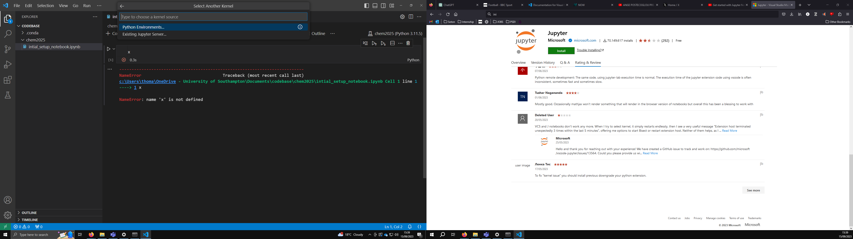Select the environment you have set up

**Let's run some code**

Add a coding cell which allows us to execute Python code

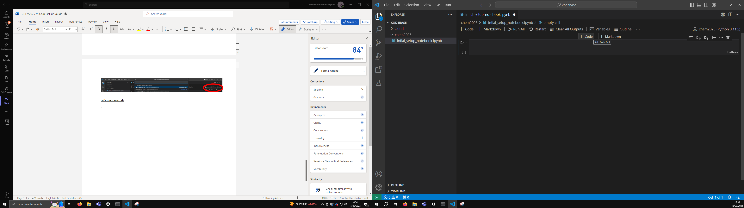

Type print(‘hello world’) into the cell and press the play button to the left of the code cell

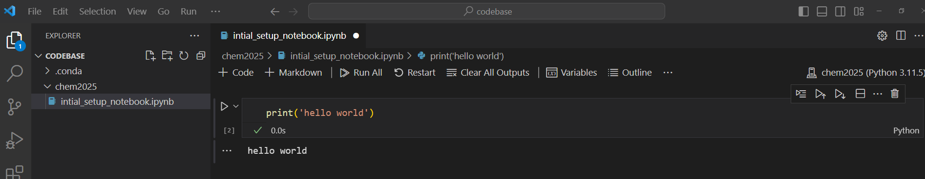We can now add a Markdown cell to explain the code

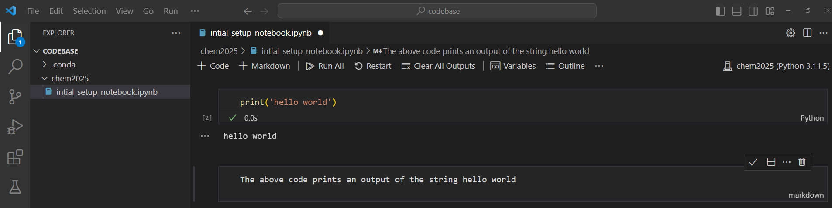Click play or shift+enter (on windows)

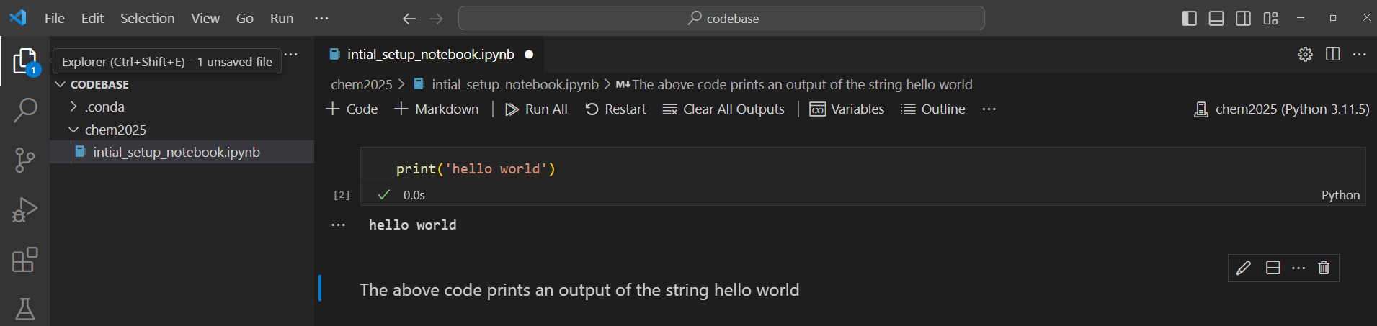

A better way to this may be to comment each line of code using # followed by a comment

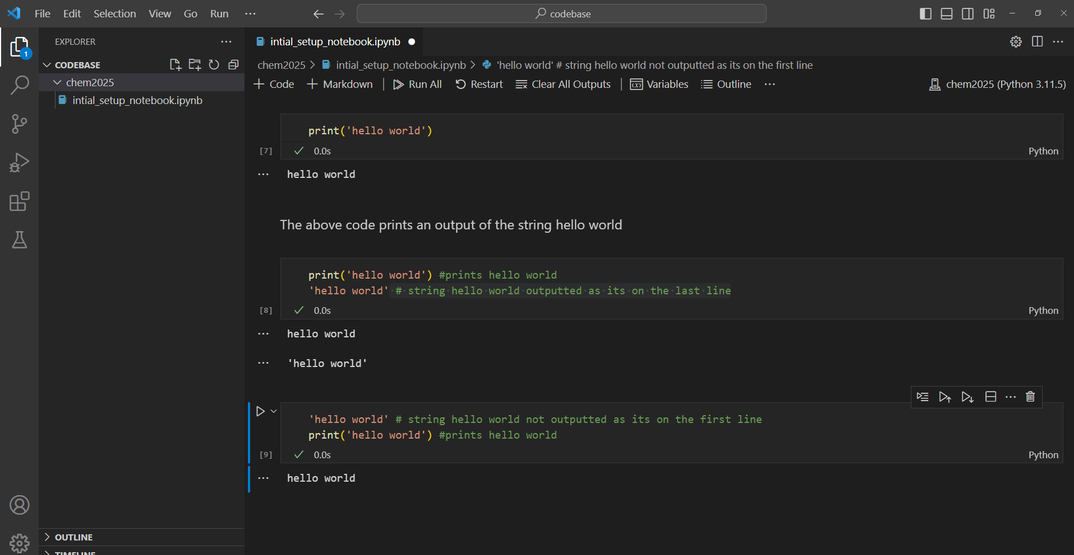

Take some time to code up and have a play with some of the behaviours of the Python Interactive Notebook

**Useful short cuts (windows)**

Click on the left of a cell and press the L key to toggle line numbers – this can be useful for debugging see below

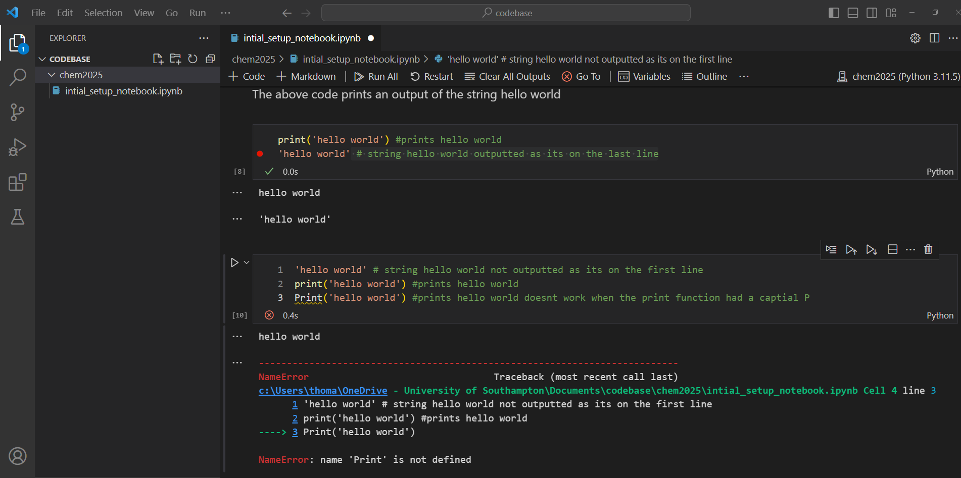

Ctrl+shift+L to select multiple patterns of you code see below

